Library Management System

(SRS Report)

Library Management System

**1. INTRODUCTION**

With the increase in the number of readers, better management of libraries system is required. The Library management system focuses on improving the management of libraries in a city or town. “What If you can check whether a book is available in the library through your phone?” or “what if instead of having different library cards for different libraries you can just have one ?” or “you can reserve a book or issue a book from

your phone sitting at your home!”.

**OBJECTIVES**

The Integrated Library Management system provides you the ease of issuing, renewing, or reserving a book from an library within your town through your phone. The Integrated Library Management system is developed on the android platform which basically focuses on issuing, renewing and reserving a book.

**1.1 PURPOSE**

The purpose of the project is to maintain the details of books and library members of different libraries. The main purpose of this project is to maintain a easy circulation system between clients and the libraries, to issue books using single library card, also to search and reserve any book from different available libraries and to maintain details about the user (fine, address, phone number).Moreover, the user can check all these features from their home.

**1.2 SCOPE**

Manually updating the library system into an android based application so that the user can

know the details of the books available and maximum limit on borrowing from their

computer and also through their phones.

The ILM System provides information's like details of the books, insertion of new books deletion of lost books, limitation on issuing books, fine on keeping a book more than one month from the issued date.

Also user can provide feedback for adding some new books to the library.

**1.3 Definition, Acronyms, Abbreviation:**

• JAVA -> platform independence

• SQL -> Structured query Language

• DFD -> Data Flow Diagram

• CFD -> Context Flow Diagram

• ER -> Entity Relationship

• IDE -> Integrated Development Environment

• SRS -> Software Requirement Specification

**2. OVERALL DESCRIPTION**

**2.1 PRODUCT PRESPECTIVE**

The proposed Library Management System will take care of the current book detail at any point of time. The book issue, book return will update the current book details automatically so that user will get the update current book details.

**2.2 SOFTWARE REQUIREMENT**

Front end:

• Android developer tool

• Advance java

Back end:

• MySQL

**2.3 HARDWARE REQUIREMENT**

* Android version 2.3 ginger bread(minimum, android user’s)
* 2GB ram
* 1.2 GHz processor
* Intel i5
* Windows 7/8/8.1/10

**2.4.1 FUNCTIONAL REQUIREMENT**

• **R.1:Register**

* + - Description : First the user will have to register/sign up. There are two different type of users.
    - The library manager/head : The manager have to provide details about the name of library,address, phone number, email id.
    - Regular person/student : The user have to provide details about his/her name of address, phone number, email id.

• **R.1.1: Sign up**

* + - Input: Detail about the user as mentioned in the description.
    - Output: Confirmation of registration status and a membership number and password will be generated and mailed to the user.
    - Processing: All details will be checked and if any error are found then an error message is displayed else a membership number and password will be generated.

• **R.1.2 : Login**

* + - Input: Enter the membership number and password provided.
    - Output : User will be able to use the features of software.

• **R.2 : Manage books by user.**

• **R.2.1 : Books issued.**

* Description : List of books will be displaced along with data of return.

• **R.2.2 : Search**

* Input : Enter the name of author's name of the books to be issued.
* Output : List of books related to the keyword.

• **R.2.3 : Issues book**

* + State : Searched the book user wants to issues.
  + Input : click the book user wants.
  + Output : conformation for book issue and apology for failure in issue.
  + Processing : if selected book is available then book will be issued else error will be displayed.

• **R.2.4 : Renew book**

* + State : Book is issued and is about to reach the date of return.
  + Input : Select the book to be renewed.
  + Output : conformation message.
  + Processing : If the issued book is already reserved by another user then error message will be send and if not then conformation message will be displayed.

• **R.2.5 : Return**

* Input ; Return the book to the library.
* Output : The issued list will be updated and the returned book will be listed out.

• **R.2.6 ; Reserve book**

* + Input ; Enter the details of the book.
  + Output : Book successfully reserved.
  + Description : If a book is issued by someone then the user can reserve it ,so that later the user can issue it.

• **R.2.6 Fine**

* + - Input : check for the fines.
    - Output : Details about fines on different books issued by the user.
    - Processing : The fine will be calculated, if it crossed the date of return and the user did not renewed if then fine will be applied by Rs 10 per day.

**R.3 Manage book by librarian**

**R.3.1 Update details of books**

• **R.3.1.1 Add books**

* Input : Enter the details of the books such as names ,author ,edition, quantity.
* Output : confirmation of addition.

• **R.3.1.2 Remove books**

* Input : Enter the name of the book and quantity of books.
* Output : Update the list of the books available.

**2.4.2 Non Functional Requirements**

• **UsabilityRequirement**

The system shall allow the users to access the system from the phone using android application. The system uses a android application as an interface. Since all users are familiar with the general usage of mobile app, no special training is required. The system is user friendly which makes the system easy.

• **Availability Requirement**

The system is available 100% for the user and is used 24 hrs a day and 365 days a year. The system shall be operational 24 hours a day and 7 days a week.

• **EfficiencyRequirement**

Mean Time to Repair (MTTR) - Even if the system fails, the system will be recovered back up within an hour or less.

• **Accuracy**

The system should accurately provide real time information taking into consideration various concurrency issues. The system shall provide 100% access reliability.

• **PerformanceRequirement**

The information is refreshed depending upon whether some updates have occurred or not in the application. The system shall respond to the member in not less than two seconds from the time of the request submittal. The system shall be allowed to take more time when doing large processing jobs. Responses to view information shall take no longer than 5 seconds to appear on the screen.

• **ReliabilityRequirement**

The system has to be 100% reliable due to the importance of data and the damages that can be caused by incorrect or incomplete data. The system will run 7 days a week, 24 hours a day.

**2.5 USER CHARACTERSTICS**

We have 3 levels of users :

• User module: In the user module, user will check the availability of the books.

* + - * Issue book
      * Reserve book
      * Return book
      * Fine details

• Library module:

Add new book

Remove books

Update details of book

Administration module:

The following are the sub module in the administration module :

1.Register User 2.Entity book details 3.Book Issue

**2.6 CONSTRAINTS**

Any update regarding the book from the library is to be recorded to have update & correct values, and any fine on a member should be notified as soon as possible and should be correctly calculated.

**2.7 FLOW DIAGRAM**

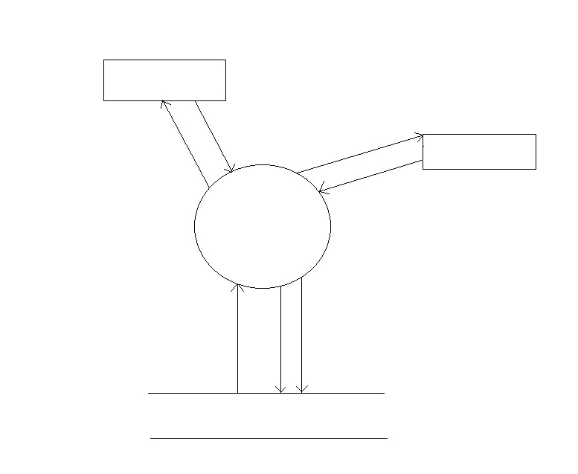

Library

Update details of books

Register/login Register/login Member

Issue, search, return, reserve books

Library Management

System

LIBRARY DATABASE

**2.8 USE CASE MODEL DESCRIPTION:**

**Use Case selection Description**

Use Case name Add student and library record

Level Sub-Functional level

Primary actor Student, Library

Stakeholders and interest Student: wants to register into the system.

Library: wants to register into the system and update book details.

Administrator: responsible for the management of the transaction of fine and also login and register details.

Pre-condition Students and Library have submitted their registration form.

Post-condition Record for a student/library has been added.

Main success scenario 1 Student/Library opens the application to access the services of the LMS

2 Student/Library sign-up to get registered online.

3 He/She provides correct information and secret password.

4 He/She got registered.

Alternative flow 1 Student/Library opens the application in their phone

2 He/She tries to sign-up

3 He/She fails and receives an error

4 He/She will report an error and the error will be rectified as soon as possible.

The response time for login is 1 minute

Specific requirement The response time for registration is 1 minute.

**Table 1: table for use case description.**

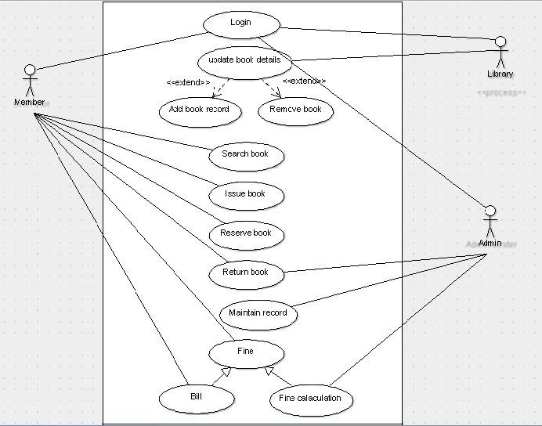

**2.9.1 USE CASE DIAGRAM**

**<<**include**>> <<**include**>>**

**2.9.2 CLASS DIAGRAM**

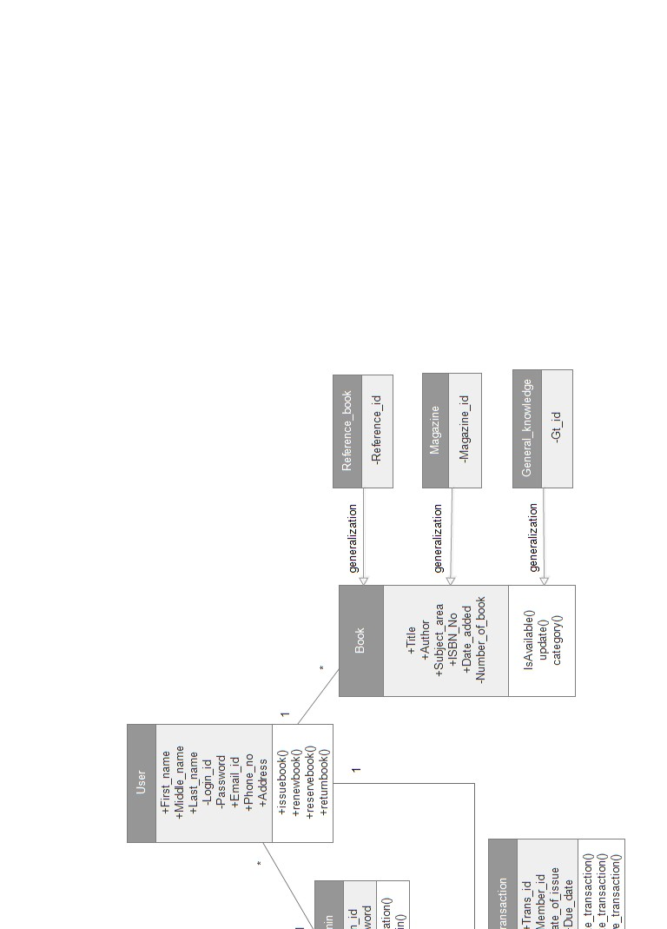

9

**Fig 2. Class diagram**

**2.9.3 Sequential diagram**

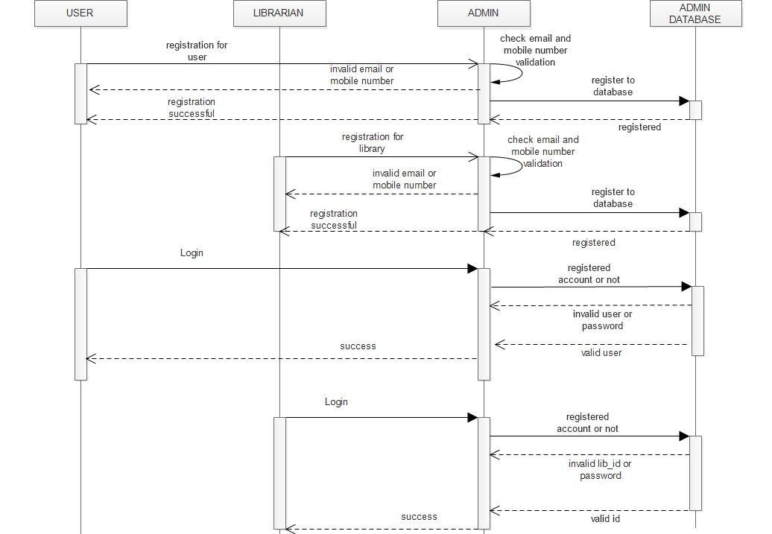

**Fig 4(a). Register and login sequence diagram**

Fig 4(b) Services user could use

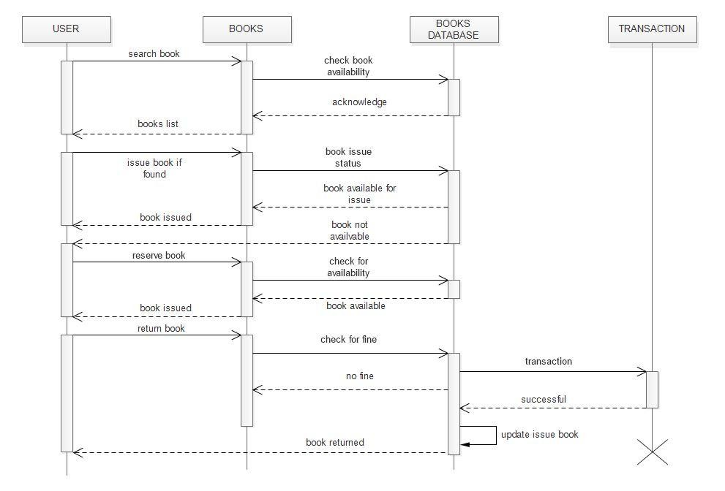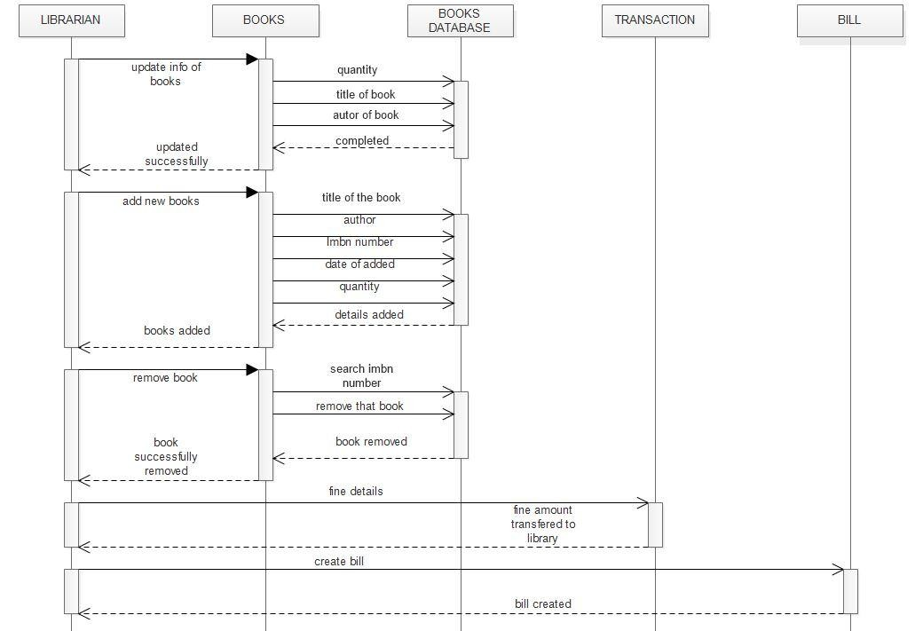

Fig 4(c) Services of a library

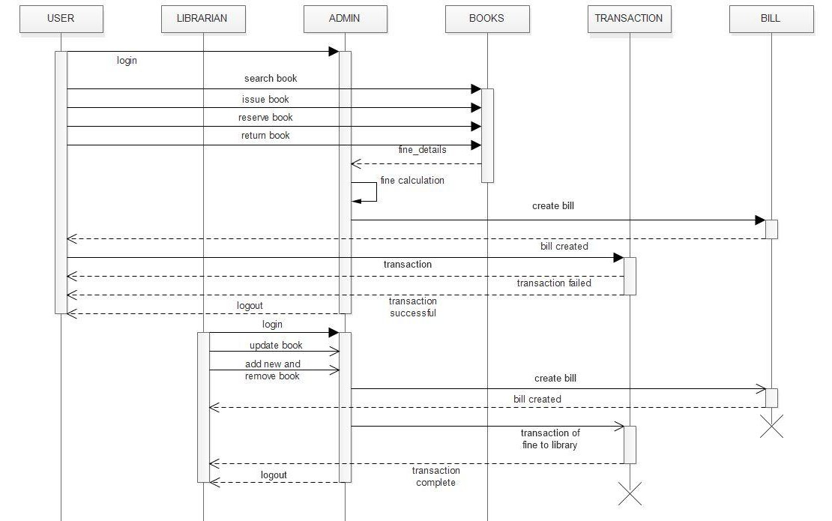

Fig 4(d) Full working of the system

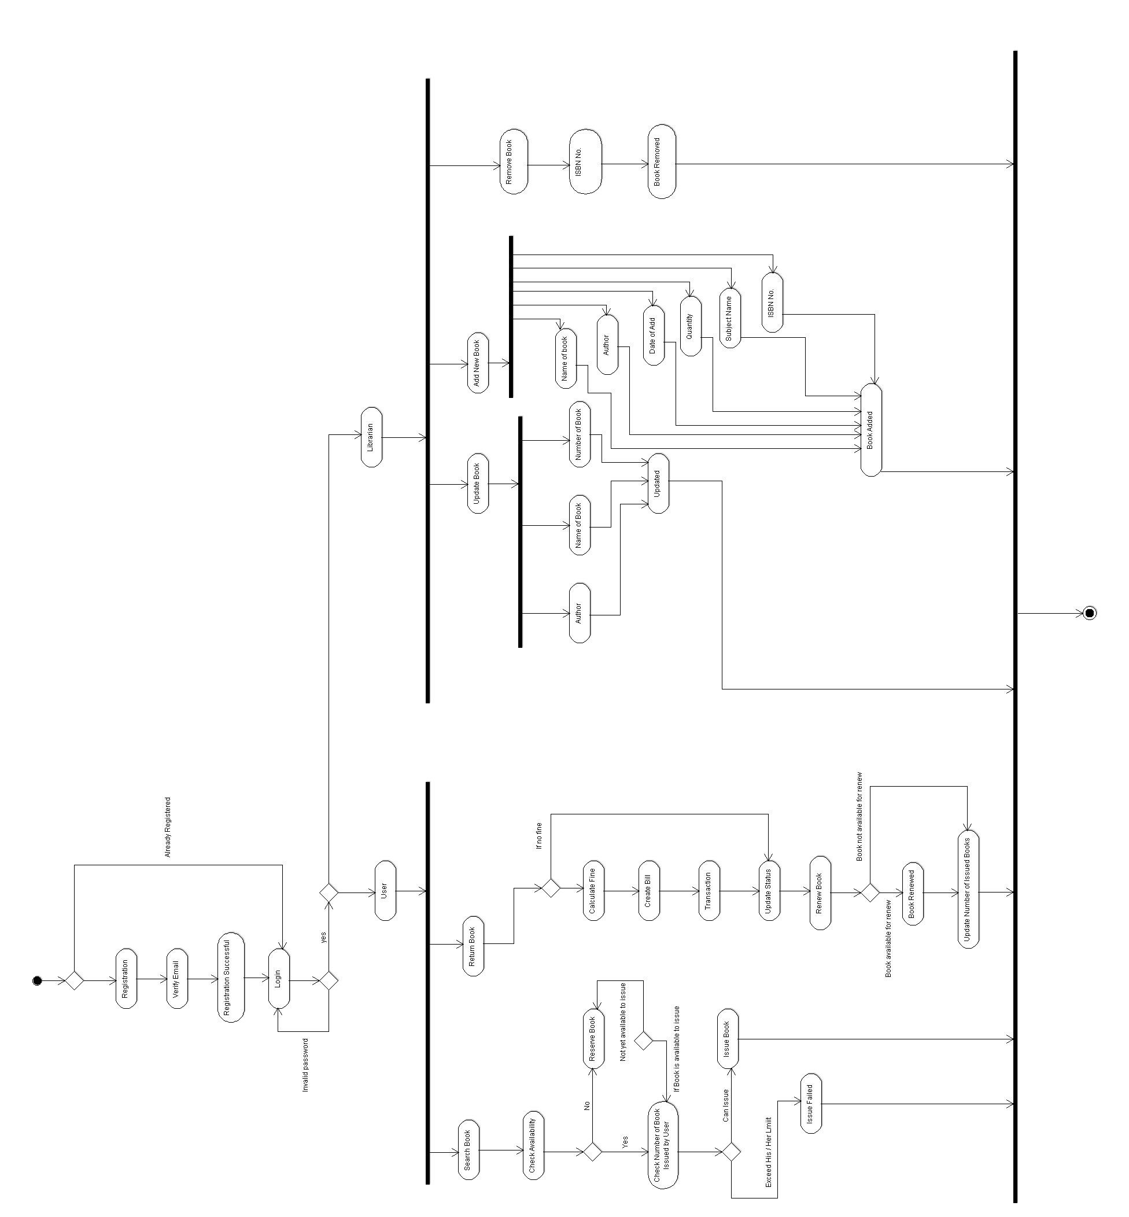

**2.9.4 ACTIVTY DIAGRAM**

**2.10 ER diagram**

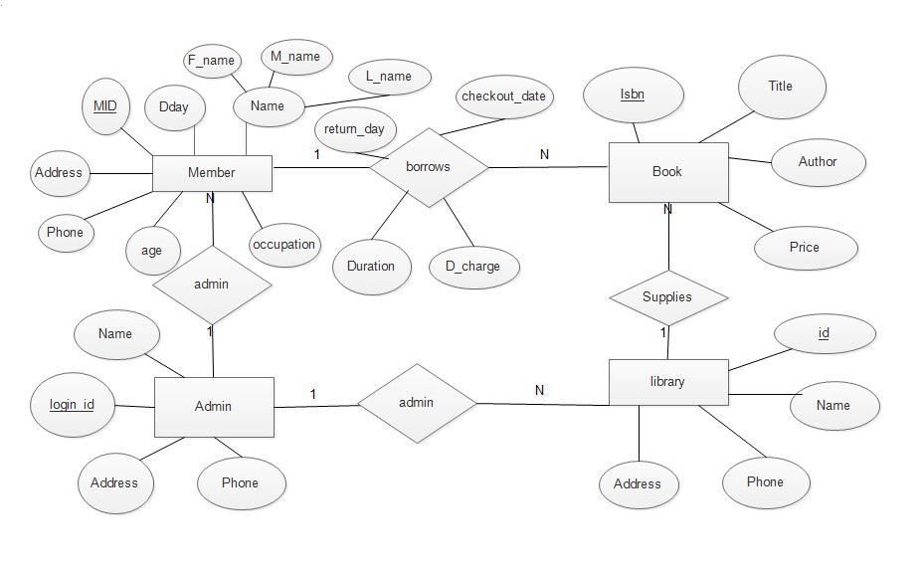

**2.11 Assumptions and Dependencies**

The product needs following third party applications for the development of the project:

• Android Studio (for development of android based applications)

• Netbeans

• Photoshop (for editing layouts, icons, buttons, etc)

**GUMMADI DIVYA**